GK7102 IP Camera

Brief Data Sheet

Hunan Goke Microelectronics Co., Ltd
2015-08-15
v0.1

Product Introduction
The GK7102 is a low power SOC chip for the development of high definition Camera IP products. It supports HD 720p30 H.264 multi-stream encoding, high quality ISP processing, and a wide range of sensor choices, built-in Ethernet, built-in PHY Audio, built-in 512MB DDR2 and Efuse encryption module.

GK7102 Function Block Diagram
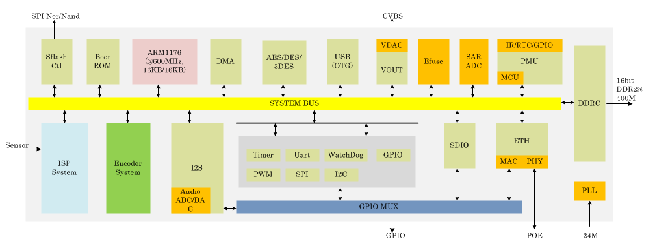

Key Specification

Processor
- ARM1176ZJFS
- Up to 600MHz
- Integrated MMU unit
- 16K I-Cache and 16KD-Cache

ISP
- Adjustable 3A（AE/AWB/AF）
- Defect pixel correction
- Image enhancement
- Black current correction
- Digital wide dynamic contrast enhancement
- 3D noise reduction
- Lens distortion correction
- ISP tuning tool provided

Video Encoder
- Support H.264 Baseline/Main/High profile L4.1
- Support JPEG Baseline format
- Real-Time multiple streams, up to 720p@30fps + 480p@30fps + QCIF@30fps + JPEG@1fps
- CBR/VBR rate control
- Support region of interest (ROI)
- Configurable GOP length, supports I/P/B frame

Audio Codec
- Support multiple audio codec protocols G.711、G.726、AAC、MP3
- Support echo cancellation

Video Interface
- Supports 8/10/12bit RGB Bayer input, a maximum of 81MHz clock frequency
- Compatibility with Sony, Aptina, OmniVision , Panasonic and other CMOS Sensor
- Compatibility with various sensor volatages
- support 1-channel CVBS output
- support OSD image overlay

Audio Interface
- Audio ADC/DAC internal integrated
- 24bit I2S input and output interfaces

Peripheral Interface
- High-accurate 32.768K RTC
- 3 x UART, including a convertible RS485
- 2 x master and slave SPI
- 2 x I2C, one is self-adaptive with sensor voltage
- 4 x PWM
- Integrated 2-channel 10bit SAR-ADC
- 1 x USB 2.0 Host/Device
- 1 x SDIO 2.0
- 1 x IR
- Integrated 10M/100M full/half duplex Ethernet PHY
- Support external PHY with RMII interface, and provide PHY clock
- 55 GPIO, which can be Arbitrary assigned according to application usage

External Storage Interface
- Internal integrated 512Mb DDR2,16bit DDR2 @ 400MHz
- SPI Nor/Nand Flash, support 1/2/4 wire mode
- Selectable Boot from SPI Nor or SPI Nand

Deep Standby
- Built in MCU
- Support infrared, buttons, GPIO alarm wake-up
- System standby current 60uA

Encryption and decryption
- Internal integrated 128KB Efuse
- Support DES/3DES/AES encryption algorithm
- Support for customer defined encryption Key

Physical
- Typical power consumption 900mW (including DDR power)
- Core voltage 1.1V, IO3.3V, DDR2 1.8V
- Operating temperature -20 ~ +85
- 11mm x 11mm, 228pin TFBGA package, 0.65 pitch

GK7102 HD IP Camera Solution

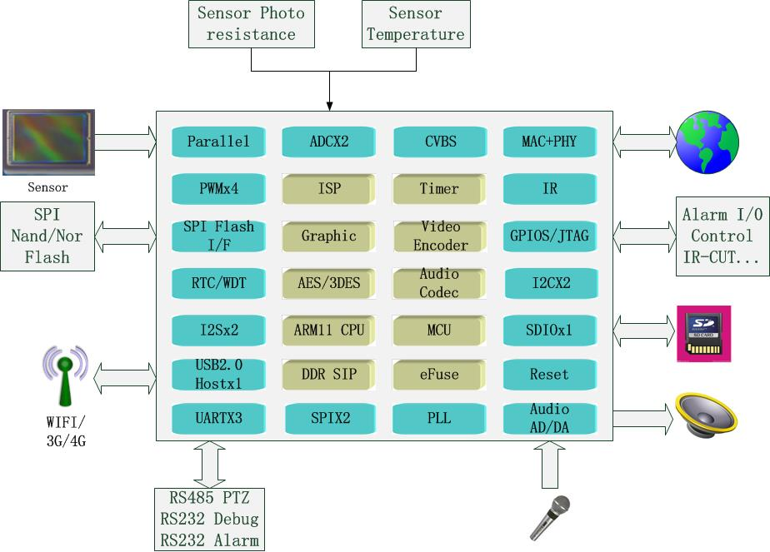

Package and Pinout
The GK710 use the package of TFBGA. It has 228 pins; body size is 11mm*11mm, ball pitch is 0.65mm.

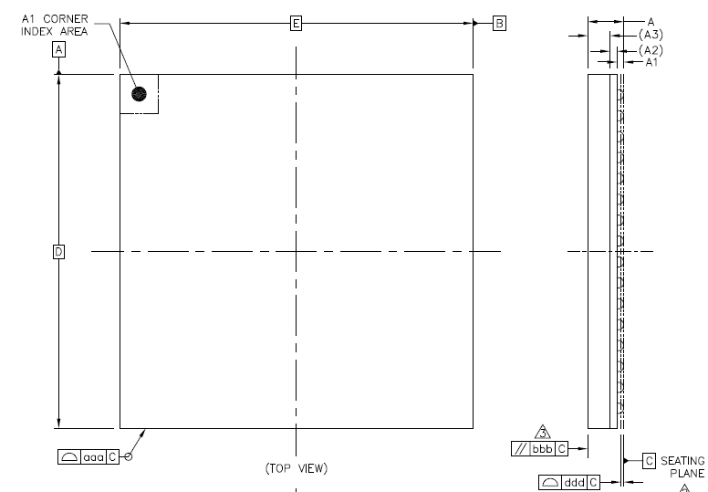
Top View

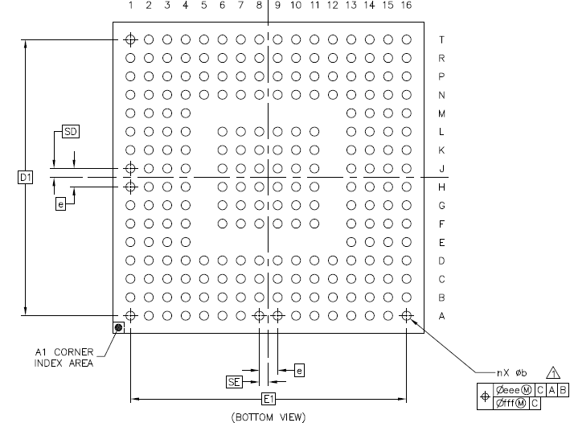
Bottom View

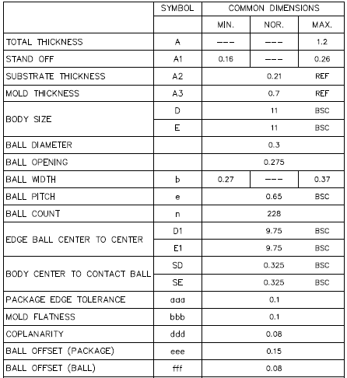

Mark Information

